Incubator project tables and graphs:

Table 1: Descriptive statistics
 | Mean | Standard deviation | Minimum | Maximum | n
Self efficacy | 13.35 | 2.1 | 3 | 15 | 11358
Self esteem | 30.83 | 7.22 | 8 | 40 | 11761
Victimization | 2.41 | 3.81 | 0 | 28 | 12851
Gender (female=1) | 0.51 | 0.5 | 0 | 1 | 12233
Age (under 18=1) | 0.43 | 0.49 | 0 | 1 | 12898
Race (White=1) | 0.65 | 0.48 | 0 | 1 | 10855
Race (Black=1) | 0.15 | 0.36 | 0 | 1 | 10855
Race (Hispanic=1) | 0.2 | 0.4 | 0 | 1 | 10855
Household type (1=Two parent) | 0.67 | 0.47 | 0 | 1 | 12848
Parents' education | 3.97 | 1.22 | 1 | 6 | 11519
Perception of self compare to others | 4.92 | 1.14 | 1 | 7 | 12618
school activity participation | 4.92 | 3.75 | 0 | 16 | 11529
Skipping class (skip=1) | 0.41 | 0.49 | 0 | 1 | 12235
Religion (attendance=1) | 0.79 | 0.41 | 0 | 1 | 9873
Delinquency | 2.11 | 2.18 | 0 | 15 | 9885

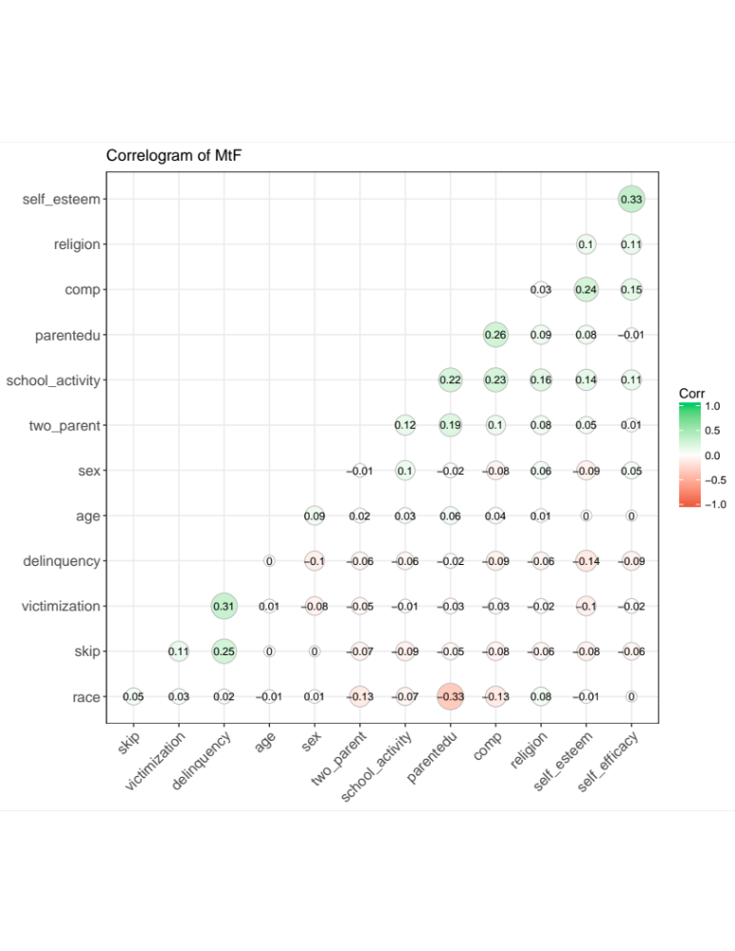
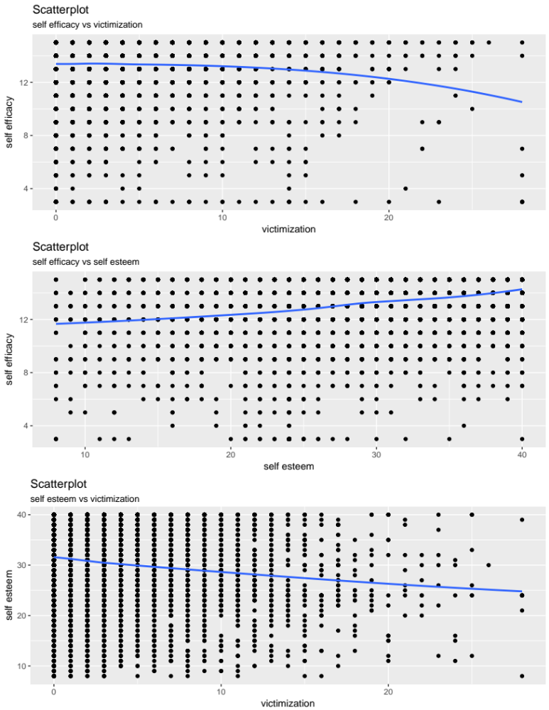

Table 2: Regression models for self-efficacy and self esteem
 | Model 1 (DV: self-efficacy) | Model 2 (DV: self-efficacy) | Model 3 (DV: self-efficacy) | Model 4 (DV: self-esteem)
Victimization | -0.028*** |  | 0.0002 | -0.282***
 | (-0.005) |  | (-0.005) | (0.018)
Self esteem |  | 0.090*** | 0.089***
 |  | (-0.003) | (-0.003)
Constant | 13.421*** | 10.566*** | 10.586*** | 31.513
 | (-0.023) | (-0.085) | (-0.088) | (0.0789)
Observations | 11,127 | 10,735 | 10,536 | 11,529
R² | 0.002 | 0.097 | 0.097 | 0.021
Adjusted R² | 0.002 | 0.097 | 0.096 | 0.02
Residual Std. Error | 2.074 (df = 11125) | 1.965 (df = 10733) | 1.953 (df = 10533) | 7.142(df=11527)
F Statistic | 27.5*** (df = 1; 11125) | 1,150.1*** (df = 1; 10733) | 562.6*** (df = 2; 10533) | 241.7*** (df=1; 11527)
Note: + p<0.1; *p<0.05; **p<0.01; *** p<0.001

